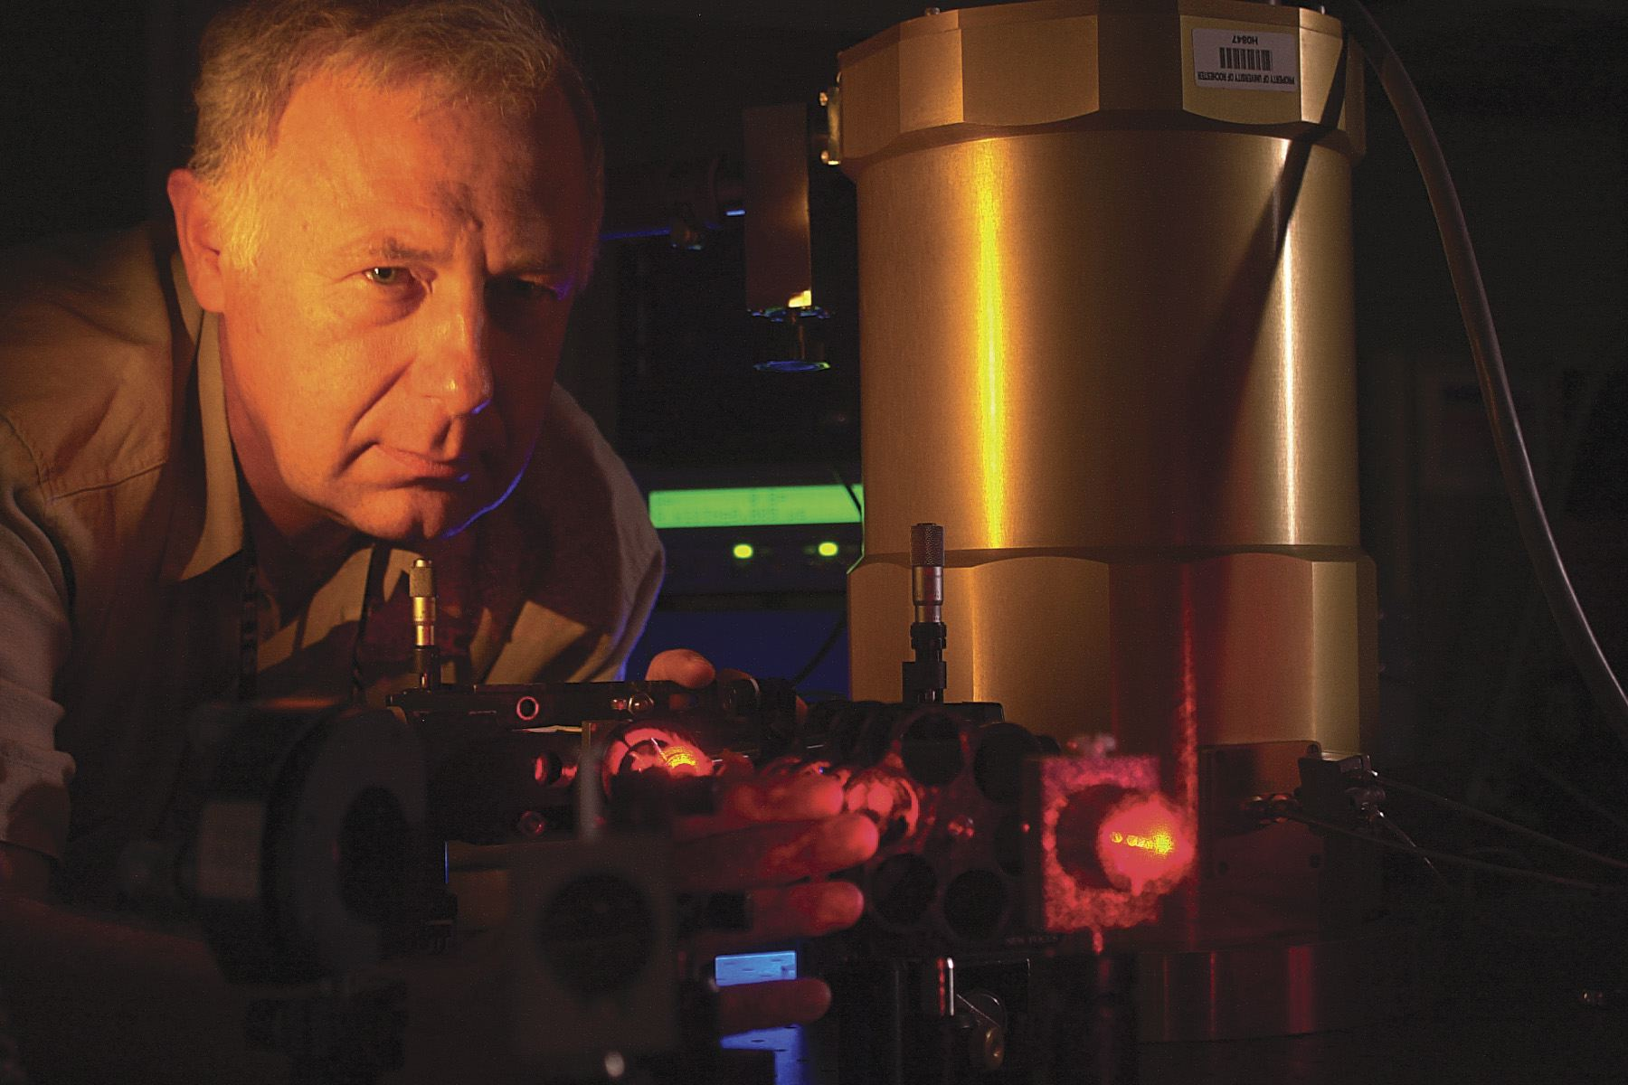

Terahertz Photonics

Roman Sobolewski
University of Rochester, Rochester, NY 14627-0231, USA
roman.sobolewski@rochester.edu

ABSTRACT

The field of THz science and technology is still in its infancy, but has already gained a very large international interest due to its numerous applications ranging from ultrahigh speed communication systems to medical imaging and diagnostics, industrial quality control, and security screening. In conventional terms, we can talk about the “THz gap,” i.e., a region of the radiation spectrum where it is very difficult to successfully operate either electronic or photonic “classical” devices. For even the fastest FET-type transistor structures, the THz frequency of operation is extremely high, while for optics the THz radiation wavelength is far too long, since the energy of THz quanta is much smaller than the thermal energy at room temperature. We present here a novel, integrated-optoelectronics approach that combines femtosecond laser pulses with materials and devices exhibiting sub-picosecond photoresponse times. We review the current state-of-the-art and advancement in THz photonics aimed towards generation and subsequent detection of sub-picosecond electrical transients for time-resolved (THz-bandwidth) characterization of novel materials and nanostructured devices. Our free-space THz spectroscopy setup is characterized by the operational frequency bandwidth of up to 4 THz and is very well suited for noninvasive tests of various electronic materials and chemical compounds. As an example, we present studies of graphene nano-flakes imbedded in a polymer medium, forming a nanocomposite with the 1% graphene content. We measured THz transmission spectra of both the pure polymer and nanocomposite and by comparing them elucidated graphene absorption, as well as its complex index of reflection and conductivity. The conductivity results follow the Drude-Smith model with the imaginary part being negative, what indicates the total backscattering of carriers within the graphene grains. In our experiment-on-chip approach, an electro-optic sampling system has been implemented for time-domain characterization of even the fastest devices, ranging from mesoscopic GaAs photodetectors to room-temperature ballistic nanostructures based on the 2-dimensional-electron-gas transport. Future prospects of THz photonics will complete our presentation.

Roman Sobolewski is a Professor of Electrical and Computer Engineering, Physics, and Materials Science, as well as a Senior Scientist of Laser Energetics at the University of Rochester, Rochester, NY, USA. He received his Ph. D. and D. Sc. (Habilitation) degrees in Physics from the Polish Academy of Sciences, Warszawa, Poland, in 1983 and 1992, respectively. In 2006, he was granted the State Professorship of the Republic of Poland. In 2011, he received the Spanish Government Research Scholarship and spent a semester at University of Salamanca, Salamanca, Spain. In 2015, he was named a Distinguished Fellow of the Kosciuszko Foundation Collegium of Eminent Scientists of Polish Origin and Ancestry.
Dr. Sobolewski’s current interests are concentrated on ultrafast phenomena in condensed matter, novel nanostructured electronic and optoelectronic semiconducting and superconducting materials and devices, single-photon quantum detection, and on generation and detection of THz radiation transients. He has published almost 400 peer-reviewed publications and communications, and presented over 200 invited conference talks, lectures, seminars, and colloquia worldwide. He is the Representative of Poland for the EU Cooperation in Science and Technology (COST) Action: Nanoscale Superconductivity.

